EXPERIMENT 12

CURSORS

**Aim:**

Create a table with attributes students and marks.

Insert values into the table.

Create a procedure, and fetch the marks of given id using a cursor.

Create a procedure, and fetch the highest marks using a cursor.

**QUERIES:**

Create a table with attributes students and marks.

Insert values into the table.

Create a procedure, and fetch the marks of given id using a cursor.

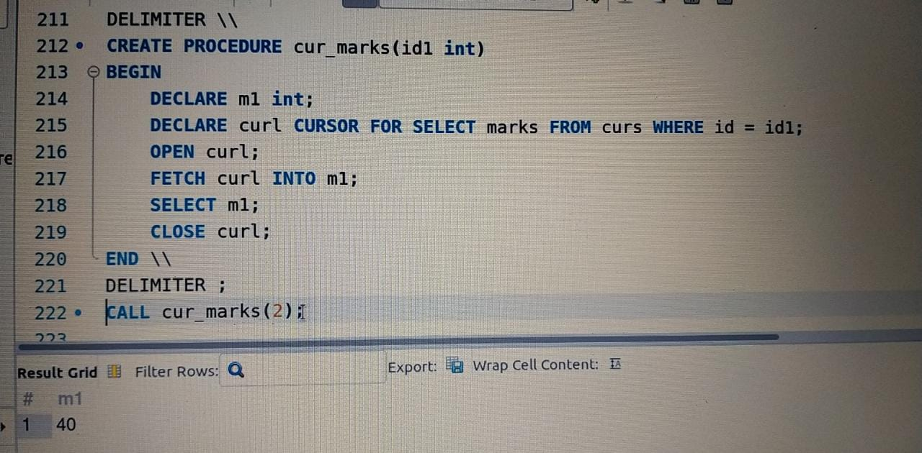

Create a procedure, and fetch the highest marks using a cursor.